**Deep Learning Based Assessment of Cognitive dysfunction based on blood test for health examination**

K Sakatani a, b, K Oyama c, L. Hu a

*a NEWCAT Research Institute, Department of Electrical and Electronic Engineering, College of Engineering, bDepartment of Neurological Surgery, School of Medicine,* C*Department of Computer Science, Nihon University, Japan*

*sakatani.kaoru@nihon-u.ac.jp*

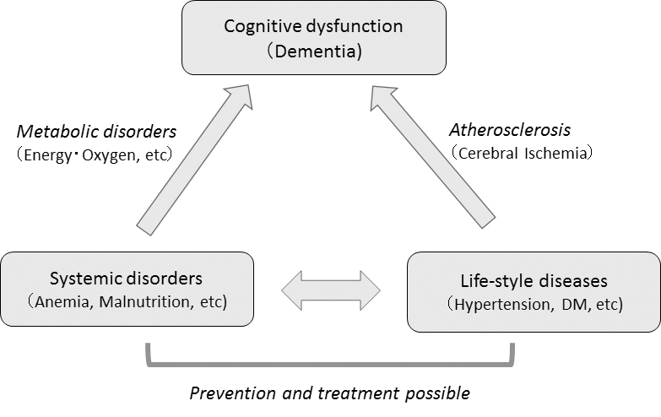**Abstract:** As the world's population is rapidly aging, dementia become a major global health problem. The Mini Mental State Examination (MMSE) is the most commonly used screening test for dementia; however, it is a subjective examination, and does not allow to examine a large number of subjects since it is carried out one by one between the inspector and the subject. In addition, the MMSE is difficult to perform on subjects with neurological disorders. In order to resolve these problems, we have developed a new screening test for dementia, which assesses cognitive dysfunction based on the basic blood test using deep learning. We studied 202 subjects (mean age 72.3±12.0 years); 68.8% of the subjects suffered from cerebrovascular diseases, while 94.6% of the subjects suffered from at least one life-style diseases. We evaluated cognitive function using MMSE; the mean MMSE scores were 24.8±4.6 (range 11~30), and performed basic blood tests of all subjects including Complete Blood Count and Basic Metabolic Panel. Employing deep learning (Feedforward Neural Network), we evaluated whether the blood test data can predict MMSE scores. The accuracy of the prediction was assessed by leave-one-out cross validation. First, we assessed whether the Deep Leaning model can predict normal and cognitive dysfunction based on the cut-off value of MMSE scores of 23/24. We observed a high prediction accuracy; 90% sensitivity and 90% specificity. In addition, we observed a significant correlation between the MMSE scores of actual measurements and predicted scores (r=0.85, p<0.001). This is the first study which demonstrates that the data of basic blood test can predict cognitive dysfunction evaluated by MMSE. This method may become a new screening test for dementia which allows to examine cognitive dysfunction of a large number of subjects in a short time and at low cost. Based on the present results, we propose that the cognitive dysfunction in elderly people with lifestyle diseases and metabolic abnormalities could be caused by the systemic metabolic disorders such as energy and oxygen metabolisms and the cerebral circulatory disturbance due to arteriosclerosis based on lifestyle-related diseases (Right Figure).

I prefer:  